Ryan Hatch

SNHU  
DAD 220  
5/18/2023

In this assignment, I used joins to combine data from multiple tables based on related columns. The type of joins that I used were specifically inner joins. An inner join returns only the matching records between the tables involved in the join. The “INNER JOIN” keyword is used to specify the join, and the ‘ON” keyword is used to define the join condition.  
I was able to retrieve the table when I selected the department name because the ‘Department_Name’ column is present in the ‘Department’ table. By joining the ‘Employee’ table with the ‘Department’ table using the ‘Department_ID’ column, I can access the columns from the ‘Department’ table in my query.  
  
The process of extracting data to a flat file was fairly straight forward. The extraction involved using a specific command that defines the I/O operations and the formatting of the data within the flat file. You specify the file name, location, and the desired location you want it to download to, along with the appropriate file extension. After running the command and extracting the data to a .csv, it is good practice to open the file and print the contents to verify that what you expected within the database was indeed saved into the flat file. To verify a .csv file, you can simply count the number of lines within the flat file. Each line in the CSV file represents a record, so by counting the lines, you will be able to verify that the number of rows in the query match the number of lines in the .csv file.

: database and contents before changes

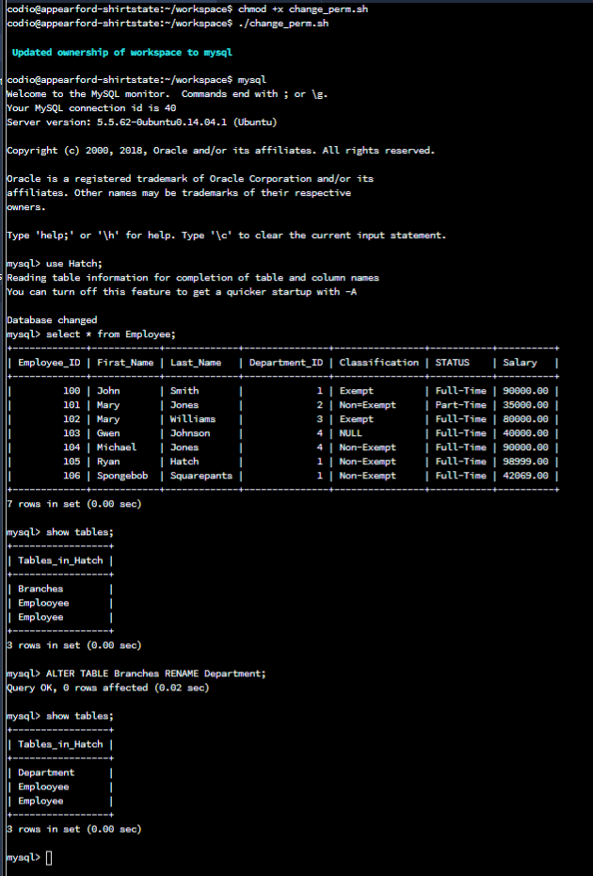

Inserting values into Department Branch, Department. It has 4 values, accounting, human resources, information systems, and marketing.

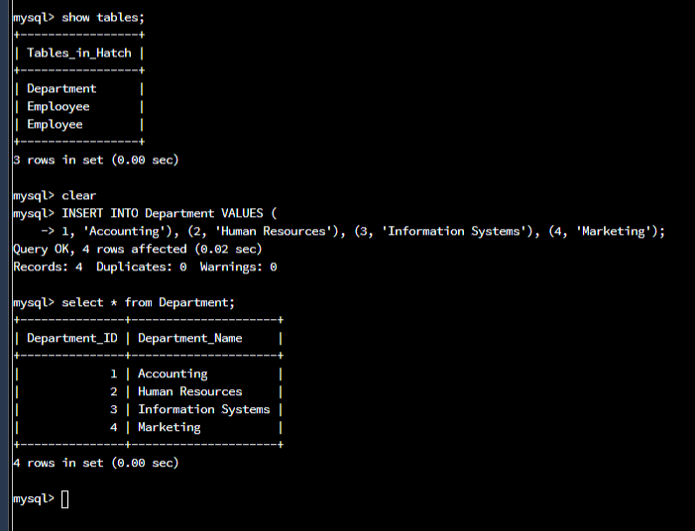

Here is where I joined between Department and Employee tables.

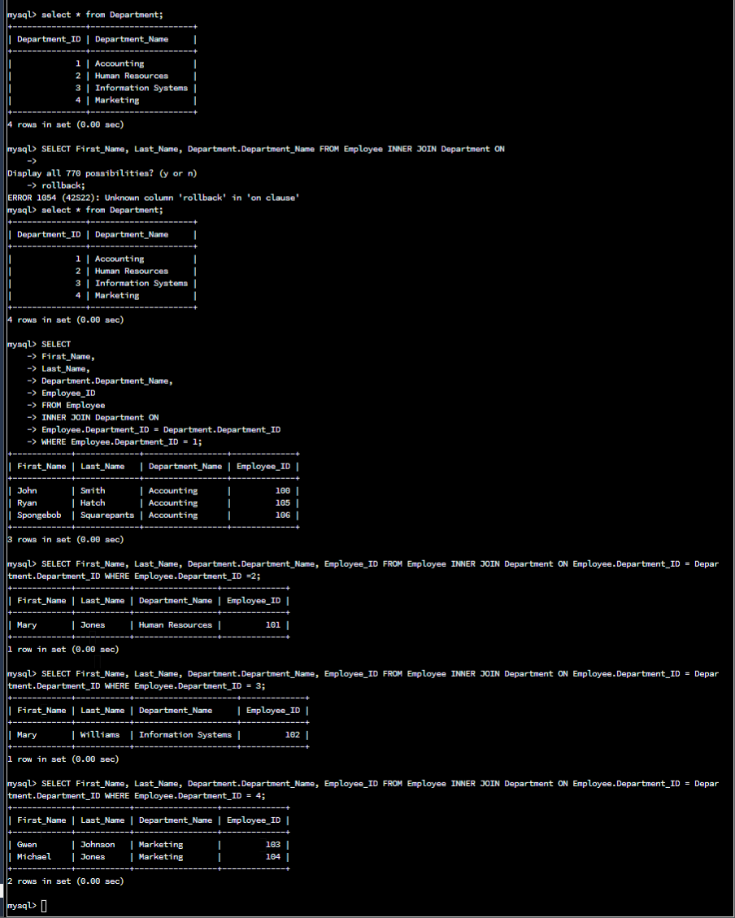

Here is me adding ten more employees and then running the tables again to show the join worked

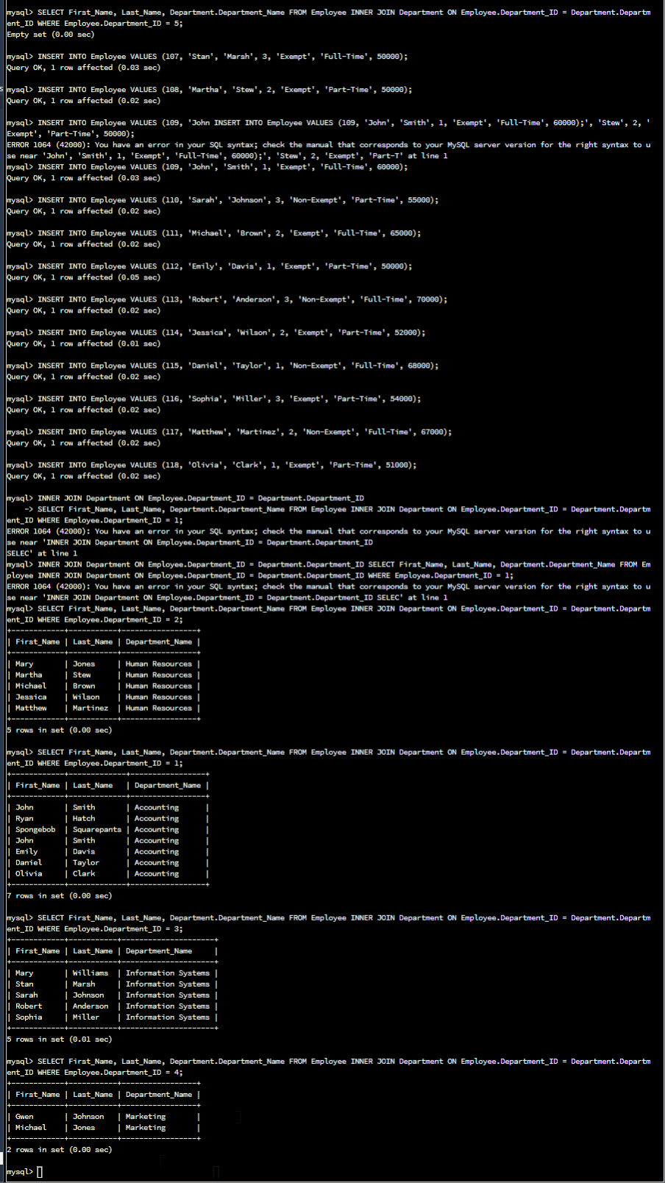

Here I exported my work into a csv file and also displayed the print

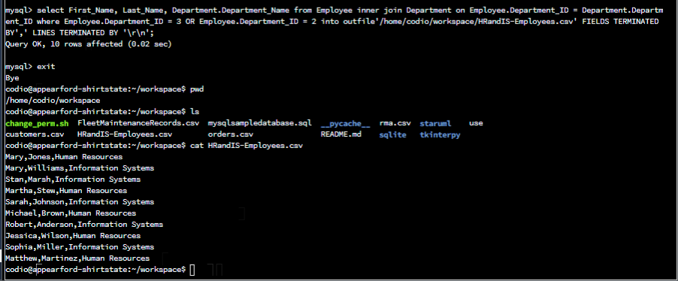

command: cat HRandIS-Employees.csv

